Kirklees Integrated System Leadership Events
Booking Confirmation Form February 2020 Events
Name
Job Title
Organisation
Contact Email

Contact Telephone

Please state if you have any dietary requirements

Please state if you have any access requirements

You have been invited to attend one of the events below. Please state which one of the events you will be attending. Please note that these are intended to be place based events so please attend the one which most closely aligns with where in Kirklees you work.
North Kirklees Event: 4th February 2020, Batley Library and Art Gallery, Batley, 9.30-3.30

Greater Huddersfield/South Kirklees: 7th February 2020, Textile Centre, Huddersfield 9.30-3.30

Please provide the name of the person who invited you to this event

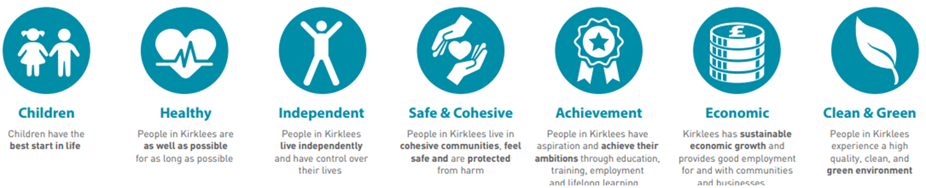
Please return the completed form to: steve.brennan@northkirkleesccg.nhs.uk

