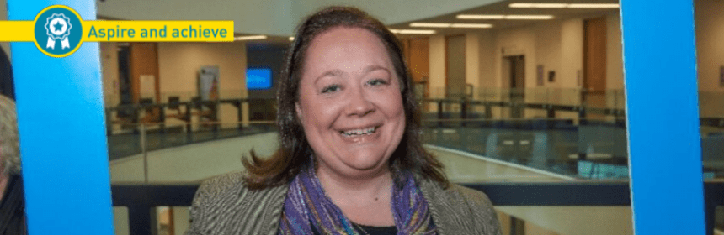

Nikki is a single parent living in Kirklees. After attending taster session funded by Community Learning Works, she has accessed a lot of employment and skills support in the district. After dealing with a lot of challenging barriers in her life she has been able to turn her life around and become an inspiration to her friends, family and her daughter, winning an Adult Learners Award in a ceremony at the University of Huddersfield.

“I am a client and volunteer at the Basement Recovery Project. Due to experiences in my life and past addiction I had lost all confidence within myself.
I was made aware of a confidence course being held at the Basement and attended a couple of taster sessions (funded by Community Learning Works). I enjoyed it so I decided to do the course fully.

My favourite part of the course included role play, team building, and communication exercises. This was challenging but helped me develop my confidence.

The tutor also invited a member of staff from C&K careers and from this I had an individual appointment at C&K and was referred to the Works Better programme facilitated by Fusion Housing where I have received much support. From there, after explaining my interests I was subsequently referred for an ECDL Level 1&2 course, which I have now completed. This has also improved my confidence and employability prospects.

I am now in the process of applying for paid employment. I am also a volunteer and advocate for the confidence course facilitated by Crosland Moor Community Learning Centre. I do this as I enjoy it and have had much success since doing it myself. This has all been in a small time frame of around four months. I am more hopeful for the future now than I have ever been in nearly ten years!”

