SCHOOL’S OUT!

Kirklees’ Holiday Activities and Food Programme for Summer 2022

Funded by
The Department for Education

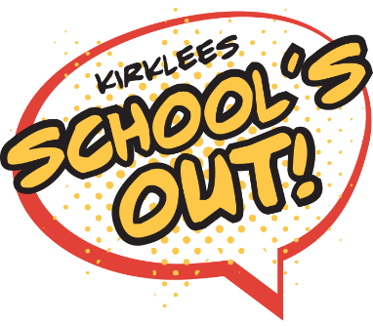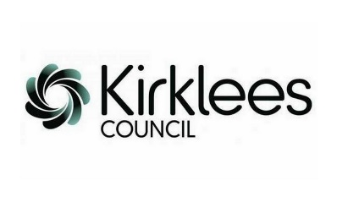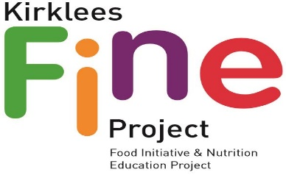
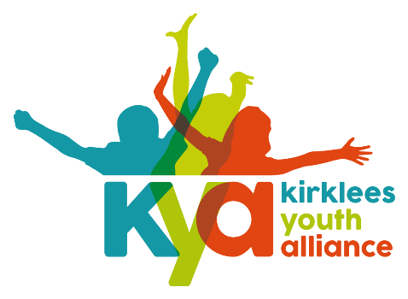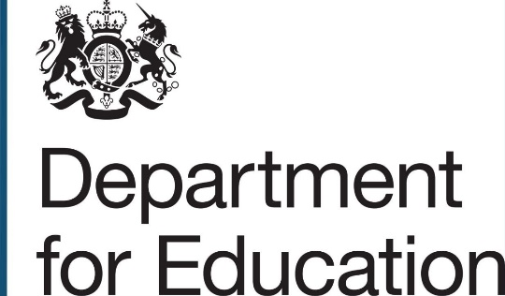

1.0 Introduction and background
1.1 Kirklees has over 15000 children and young people eligible for free school meals (FSM); the highest percentage in West Yorkshire and the second highest in the Yorkshire and Humber region. FSM is one of the key indicators of child poverty in an area, with the impact acutely felt in the long summer holiday.
1.2 In its April 2019 report, the Child Poverty Action Group highlighted the plight of 3 million children now living in working households in poverty after housing costs have been paid. The school holidays present additional financial hardship for many households due to a reduction of income, increased childcare costs, increased food bills and spending on recreational activities to keep children occupied.

1.3 Over the last few years, “holiday hunger” has become a huge concern. According to the 2017 APPG “Hungry Holidays” report, research has shown that in long holiday breaks as well as going hungry, some children’s learning and behaviour also go backwards.

1.4 Kirklees Council and Kirklees Youth Alliance CIO have worked in partnership over the last two years to develop the Healthy Holidays Programme of provision for children and young people eligible for FSM.

1.5 In late 2020 the Department for Education announced funding to all local authorities in England to deliver the Holiday Activities and Food Programme (HAF).

1.6 From 2021, HAF is funding the provision of a healthy meal, nutritional education, physical exercise and enrichment activities for benefits related Free School Meal children and families. The model the DfE encourages is free of charge clubs to be run using a 4X4X4 model i.e. provision should last for 4 hours over 4 days of the school holidays.

1.7 In Kirklees, we are continuing to use the name School’s Out! for our programme. The summer school holidays commence on Wednesday 27 July 2022 and end on Friday 2 September 2022. We would like the programme to be delivered in a four week period between Monday 1 August and Friday 26 August

1.8 Provision will be delivered by a wide range of community partners in a wide range of community-based settings.

1.9 Activities will be promoted by the funded providers. Providers need to ensure that children and young people accessing the provision are entitled to benefits related free school meals. Once activities have been delivered providers will be expected to provide registers of children attending using funding, to Kirklees Council
1.10 All providers will need to ensure that the activities delivered adhere to COVID safe practice. Additional discussions will take place in the run up to the activities based upon the latest guidance.

2.0 Specification
2.1 Activities must take place in the geographical areas identified in the EOI form. They should have a fixed base but could include activities off site.
2.2 Provision must take place between Monday 1 August 2022 and Friday 26 August 2022. If you wish to deliver outside of these days/times please indicate the rationale behind this on the application form(s)
2.3 Activities should take place for a minimum of four hours. If you wish to run for shorter periods please explain the rationale for this in your application and explain how the provision of a meal will be included with the session
2.4 Please indicate on the form which cohort the activities will be for (you can select more than one). The choices are:
- Children aged 4 – 8
- Children aged 8 – 12
- Young People aged 12+
- SEND Children / young people
- Activities involving families
2.5 Organisations will promote their offer appropriately. Organisations are expected to share copies of their promotional materials with Kirklees Council and recognise in any promotional materials the source of funding – Department for Education’s Holiday Activities and Food Programme. Organisations will be expected to evidence that the child or young person is entitled to benefits related free school meals (self-declaration by parent/carer). All places funded by this programme are for benefits related free school meal children only unless agreed
2.6 Organisations will manage their own booking systems for the offer. Organisations will be expected to take essential details of children attending including name, DOB, address, FSM status, additional support needs, and emergency contact details. Funded organisations will also need to ensure they have details regarding food allergies, preferences or intolerances. Copies of these registers will be shared with Kirklees Council following delivery of the programme.
2.7 Activities can be delivered by one organisation or a partnership of two or more organisations.
2.8 Clubs should include some physical exercise.
2.9 Provision must include an enrichment activity. Children and young people must try new things or learning something new whilst taking part in the School’s Out! Programme. “Enrichment” includes activities like arts and crafts, creating music, writing poetry, raps or songs, cooking, gardening, nature walks, bush craft, life skills etc. We would also like providers to consider food nutrition activities with children, young people and their parents / carers as part of the offer.
2.10 Funded activities must include a food nutrition activity as part of the four hour offer. Additional support is available to develop these activities from the FINE team.
2.11 Organisations must not charge any children or young people for attending the provision that has been funded using HAF allocated monies.
2.12 Provision must be as inclusive as possible. Organisations must not discriminate on grounds of race, religion, gender or sexuality. Regarding SEND (special educational needs and disability), organisations should accommodate children and young people wherever possible.
2.13 Applicants should be (where applicable) registered with either i) the Kirklees Grant Access Point , ii) OFSTED and/or iii) Kirklees Youth Alliance. If you are not registered with either of these then funding may not be available or significantly reduced.
2.14 Any staff involved in the delivery are expected to have a current enhanced DBS check in place. Details may be checked by Kirklees Council upon request.
3.0 Specification – HAF Expression of Interest form – Including Food
3.1 Sessions delivered must include a nutritious healthy meal for the children, young people and where possible their parents or carers attending provision. This is reflected in the allocation of funding available to support the offer.
3.2 If you intend to prepare the food on site, in order to be successful in the application for funding you will be expected to have in place the following –
- Registered as a food business with Kirklees Environmental Health and have a hygiene rating of 3 or above
- Relevant up to date food safety qualifications for staff supporting the food offer ie level 2 food safety or equivalent.
- Suitable premises/equipment to prepare and serve food safely.
- Written procedures on safe food preparation, which will depend on the scope of the food provision i.e.
  - If the ‘community kitchens’ document covers the risks of what they're doing then this can be implemented along with the food hygiene checklist for daily records. (Included with Additional Information Pack
  - Should the community kitchens document be inadequate, ie they are doing more advanced food preparation/etc then they should use the relevant bits from Safer Food Better Business (SFBB) for caterers (Safer food, better business for caterers | Food Standards Agency) If there are different people doing the food preparation on different days etc, in addition to the SFBB the checklist would be a good way of maintaining daily records, rather than the use of the SFBB diary.
- Food Safety procedures to include preparing food safely for those with food allergies and intolerances
- Procedure in place to take details of allergies / intolerances of children attending
- Ensure that the food offer meets the dietary requirements of attendees
- Suitable insurance in place to provide food
- Agree to ensure that the food offered is healthy and nutritious

3.3 If you intend to work with a food business to supply food/meals then in order to be successful in the application for funding, you will be expected to ensure the provider meets the following criteria –
- The supplier has a hygiene rating of 3 or above to provide food (details will need to be provided)
- Relevant up to date food safety qualifications for staff supporting the food offer ie level 2 food safety
- Suitable and adequate Food Safety Management System ie SFBB or own inhouse HACCP procedures.
- Procedure in place to take details of allergies / intolerances of children attending
- Ensure that the food offer meets the dietary requirements of attendees
- Agree to ensure that the food offered is healthy and nutritious

4.0 Finances and payment
4.1 The amount allocated will be £27.50 per child for a minimum of 4 hours. This payment includes the cost of a meal for the child / young person.
4.2 Upon return of the award letter 50% payment will be released to organisations, with the remaining 50% paid upon competition of offer and return of required monitoring.
5.0 Application process
5.1 Providers are asked to complete the application form here:
Activities including food https://forms.office.com/r/XAsfh09BJH
5.2 If you would like a PDF version of the application form then please contact us at HAF@Kirklees.gov.uk
5.3 Applications are invited from Monday 9 May 2022 until 5pm on 3 June 2022
5.4 Applications will be considered by the Holiday Activities and Food panel week commencing Monday 13 June 2022
5.5 Providers will be notified of the outcome from Monday 20 June 2022

7.0 Additional information and links

7.1 For additional information please contact HAF@kirklees.gov.uk or hello@Kirkleesyouthalliance.org
7.2 For any information relating to the provision of food please contact fine.project@kirklees.gov.uk
7.3 For any information regarding Grant Access Point please contact thirdsector@kirklees.gov.uk

