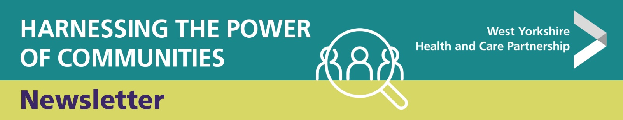

27 January 2023
Welcome to the Harnessing the Power of Communities (HPoC) newsletter. Our HPoC Programme works with the voluntary, community and social enterprise sectors (VCSE), acting as a catalyst for change, facilitating new opportunities for VCSE organisations to better engage in shaping services and decision making, and challenging the ways we work in health and care to ensure greater inclusivity and accessibility in commissioning and service provision.
If you have a question or comments about anything included in this newsletter, please get in touch with the team via email: wyicb-wak.hpoc.program@nhs.net

North East & Yorks Thriving Communities - activities coming up

Please find below a link to our latest network communication featuring forthcoming regional Thriving Communities programme events.
Thriving Communities event news January 2023
We’d appreciate if you’d share what’s coming up with members of your own networks and encourage people to participate in the activities that are coming up.
……………………………………………………………………………………..
Stakeholder Update

Following an extensive engagement process, NHS England national mental health team is delighted to announce a new name for Improving Access to Psychological Therapies (IAPT) services: NHS Talking Therapies. Thank you to those of you who shared your feedback with us, we appreciated your input and have conducted an in-depth analysis of all the responses we received (close to 4,000!).
The new name will be rolled out in all services across the country in 2023 and will be accompanied by the following tagline: for anxiety and depression. This rebranding exercise will be critical in raising the profile of talking therapies and removing barriers to access. Our feedback analysis demonstrated that the name NHS Talking Therapies felt more accessible to the public and easy to understand, and that it described the scope of IAPT services better. This was the key aim of this rebranding exercise from the beginning.
As we are now entering the implementation phase of the new name, we would like to ask for your support in updating relevant communications channels and materials referring to IAPT, and in promoting NHS Talking Therapies within your networks.
If you have any questions, please contact england.mhcomms@nhs.net
……………………………………………………………………………………..
Social Enterprise UK (SEUK) Event
Social Enterprise UK and NHS England System Transformation team are hosting a series of regional roundtables to develop collaborative relationships to ensure the value and expertise of social enterprise is harnessed to benefit health outcomes for people and communities.
The roundtables will highlight challenges as well as emerging positive practice. The discussion will focus on several key areas for further policy working and support around three areas:
- Awareness and understanding of Social Enterprise and Community Interest Companies and their contribution to care systems
- Parity for Social Enterprises within ICS, including professional development and pay for staff
- Transparency around the Provider Selection Regime

The events will take place on:
- 21 February, 10:00am-11:30am, Yorkshire and the Humber, register here
- 23 February, 10:00am-11:30am, South East, register here
- 28 February, 10:am-11:30am, South West, register here
The roundtables are open to anyone interested in finding out more about the valuable role Social Enterprise and Community Interest Companies play in delivering services, decision-making and planning at system level and working through challenges and potential solutions to develop partnership working.
If you have any questions, please email england.sspp-office@nhs.net .
……………………………………………………………………………………..
Webinar: Data tools to assess the wider determinants of health

Please find below details of two webinars from our Local Knowledge and Intelligence Team (LKIS) and a recording of one on Health Inequalities. The second may be of particular interest. Click on their KHUB link to keep up-to-date with their excellent data tools, reports and products.
- Webinar series: Data tools to investigate health inequalities in NEY online events – slides and recordings available for first 3 webinars will be available on KHub
Other planned events in the series:
Tues 24 Jan 2023 1pm – 2pm: Data tools and resources to assess inequalities in healthy ageing indicators (sign up now via Eventbrite)
Tues 31 Jan 2023 1pm – 2pm: Data and tools to assess the impact of wider social determinants of health and placed based inequalities (sign up now via Eventbrite)
……………………………………………………………………………………..
Carbon literacy training
Health and care colleagues across West Yorkshire are invited to join a free all day online event around carbon literacy to find out more about the scale and urgency to meet NHS net zero and other sustainability targets. The event will be repeated on three days from 9.30 to 4 on:

- Monday 6 February
- Thursday 9 March
- Monday 17 April

The training provides learners with an awareness of the costs of carbon dioxide and other greenhouse gases and the impacts of climate change on everyday activities. This includes the services we provide, the goods we purchase and the lives of our patients, service users and colleagues. We also consider how we will need to adapt to be resilient to our changing weather.

Emma Clarke, Energy, Waste and Sustainability Manager at Bradford District Care NHS Foundation Trust will host the training.

To book and for more information see the eventbrite pages. Places are limited so please only book for your preferred day.

Upon successful assessment, you will be awarded a uniquely numbered certificate to evidence your carbon literacy, and confirm that you have met the requirements of the Carbon Literacy Standard.
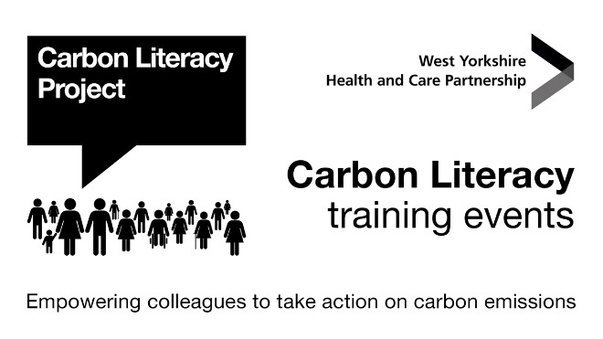
……………………………………………………………………………………..
Support for young pregnant women to quit smoking launches
Support for young pregnant women to quit smoking launches

West Yorkshire Health and Care Partnership (WY HCP) launches a new campaign, today, Monday 30 January 2023 to create awareness and support for pregnant women wanting to quit smoking.

The campaign highlights tobacco use as the leading preventable cause of miscarriage, stillbirth and neonatal deaths. Despite these risks being well told, according to NHS research^{[1]} 8.8% of UK mothers were smokers at the time of delivery. For West Yorkshire, the figure is higher at 11.5%.

The data^{[2]} shows only 50% of pregnant women who smoke are motivated to stop without wider incentive or intervention. The campaign, which focuses on younger women aged 18-25, aims to ensure those that want help, know how to access it.

Robin Tuddenham, CEO for Calderdale Council and co-chair of the WY HCP’s Improving Population Health Programme said: “We are committed as a health and care partnership to doing all we can to support pregnant women who want to stop smoking. Evidence has shown that babies born to smokers experience health effects that extend into childhood, for example low birth weight, weak lungs, more sick days and asthma - many things that can be prevented. This campaign aims to reduce the number of young mums known to be smokers at the time of delivery by providing the right support at the earliest stages possible. It’s never too late - every day makes a difference to both mum and baby’s health.”

Dr James Thomas, Medical Director, NHS West Yorkshire Integrated Care Board and co-chair for WY HCP’s Improving Population Health Programme said: “All forms of tobacco are harmful, and there is no safe level of exposure to tobacco. As the leading preventable cause of miscarriage, stillbirth and neonatal deaths we must continue to do more across our region to ensure those that want help, know how to access it. We hope that many pregnant women will find support to help them to stop smoking by visiting: www.mums-can.co.uk.

Diane Tinker, Director of Midwifery and Women’s Services, Calderdale and Huddersfield NHS Trust, said: “Local insight has helped us to develop this new campaign and understand more about what breaking the habit really means for local women. Mums Can is a local website which signposts pregnant women to free, friendly, non-judgemental support, safer alternatives and proven techniques to help them make a change. There are safe replacements for smoking during pregnancy and stopping helps immediately, it’s never too late to quit.”

The NHS Long Term plan sets out that by 2023/24, all people admitted to hospital who smoke will be offered NHS-funded tobacco treatment services. As part of the NHS ambition for a smokefree generation, the model will be adapted for pregnant women and their partners. The approach includes a new smokefree pregnancy pathway with focused sessions and treatments.

With this backdrop, WY HCP created a campaign to support pregnant women to access smoke cessation services. The campaign addresses the barriers and promotes facilitators that could increase engagement with the healthcare professionals skilled to deliver behaviour change among young pregnant women.

We developed the campaign resources following a literature review of latest best practice, insight from local pregnant women and the experience and the views of regional healthcare professionals. This research highlighted the need for a non-judgemental campaign that focused on a woman’s self-determination and self-belief that – with support – positive health choices and change is possible. It also showed the importance of a supportive partner and peer group in influencing a woman’s decision to stop smoking.

The resources can be used across various channels – in person and virtually, such as WhatsApp groups, on Facebook, Instagram and Twitter, in workplaces, community groups and elsewhere by downloading them at www.mums-can.co.uk from 30, January 2023.

All partners in West Yorkshire – health, care, voluntary community social enterprise sector and beyond, are encouraged to download the free resources, such as posters, social media messages and an animation to use in their organisation, place of work, teams or at home among friends, family and their community. All are available at www.mums-can.co.uk.

……………………………………………………………………………………..
ASIST suicide prevention training

ASIST Training
9th and 10th February 2023, 9-5pm, Featherstone Rovers
Applied Suicide Intervention Skills Training (ASIST) is a two day interactive workshop in suicide first aid and more. ASIST teaches participants to recognise when someone may have thoughts of suicide and work with them to create a plan that will support their immediate safety. Although ASIST is widely used by healthcare providers, participants don’t need any formal training to attend the workshop – anyone 16 or older can learn and use the ASIST model.
Since its initial development in 1983 by LivingWorks, ASIST has received regular updates to reflect improvements in knowledge and practice, and over 2,000,000 people worldwide have taken the workshop. Studies show that the ASIST method helps reduce suicidal feelings in those at risk and is a cost-effective way to help address the problem of suicide.
Since 2013, ASIST 11 is the most recent version. For those trained in ASIST 10 or earlier, signing up for an ASIST 11 training is recommended.
“Cutting edge, front-line, hands on, LIFE SAVING resource, made highly accessible and instantly applicable. The kind of training that keeps people alive.” An ASIST participant
What is ASIST?
An accredited two day, interactive training that prepares caregivers to provide suicide first aid interventions.

Who can attend ASIST?
Anyone 16 or older (despite previous training) can learn and use the ASIST model. No previous mental health or suicide prevention experience is necessary.

What will you learn as an ASIST trained first aid caregiver?
After taking ASIST, you will be better able to:
- Be suicide alert – identify people who have thoughts of suicide
- Understand the reasons behind thoughts of suicide and the reasons for living
- Assess risk and safety – develop a plan to increase the safety of the person at risk of suicide
- Recognise invitations for help
- Recognise potential barriers of seeking help
- Offer support – recognise other important aspects of suicide prevention including life-promotion and self-care
- Effectively apply a suicide intervention model
- Link people with community resources

What are the workshop features?
- Presentations and guidance from two LivingWorks registered trainers
- A scientifically proven intervention model
- Powerful audio-visual learning aids
- Group discussions
- Skills practice and development
- A balance of challenge and safety
- Participant materials include a 20-page workbook, wallet card, and stickers. Participants also receive a certificate upon completing the workshop.

What is the structure of an ASIST workshop?
The ASIST workshop is divided into five sections that follow in a logical progression to gradually build comfort, confidence and understanding around suicide and suicide intervention.
Preparing: Sets the tone, norms, and expectations of the learning experience over the two days.
Connecting: Enables participants to reflect on their own attitudes towards suicide. This creates an understanding of the impact that attitudes can have on the intervention process.
Understanding: An overview of the intervention needs of a person at risk. The trainers focus on providing participants with the knowledge and skills to:
- recognise risk
- develop safeplans to reduce the risk of suicide
- increase the safety of the person
Assisting: Presents a model for effective suicide intervention. Participants develop their skills through observation and supervised simulation exercises in large and small groups.
Networking: The trainers share information about resources in the local community and promote participant commitment to encouraging the transformation of local resources into helping networks.
Click here to complete our Expression of Interest Form.

……………………………………………………………………………………..

[1] Statistics on Women’s Smoking Status at Time of Delivery: England, Quarter 3, 2021-22. 24 March 2022
[2] Smoking in Pregnancy research group - The University of Nottingham

