
04 April 2025
Welcome to the Power of Communities newsletter. Our Power of Communities Programme works with the voluntary, community and social enterprise sectors (VCSE), acting as a catalyst for change, facilitating new opportunities for VCSE organisations to better engage in shaping services and decision making, and challenging the ways we work in health and care to ensure greater inclusivity and accessibility in commissioning and service provision within the West Yorkshire Health and Care Partnership.

If you have a question or comments about anything included in this newsletter, please get in touch with the team via email: wyicb-wak.hpoc.program@nhs.net


Hearing the voice of the VCSE Sector and training offers
In this section we have a list of surveys, information requests or workshops that are
happening across the West Yorkshire Health and Care Partnership and we want to
ensure the voice of the VCSE sector and communities you support are fully represented

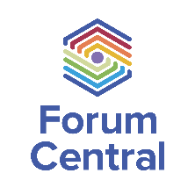
Leeds Third Sector Cost Pressures Survey: Share your organisation’s current challenges and financial position
This is to help Forum Central and partners understand and present an up to date picture of the sector in terms of sustainability - and the impact of financial pressures on your organisation, including risks relating to your staff, services, and organisation viability.

Complete the short survey here by 07 April: Spring 2025 Cost Pressures Survey
(googleforms no sign-in required) (https://forms.gle/sDeBCw8mzgvhV5jZ8)


Northern Race Equality Conference
Date: Weds 09 April, 9am-4:30pm at University of Bradford
Click here to find out more and sign up
The Conference will bring together activists, advocates, organisations, lawyers, researchers, and academics committed to building a better society, one where racial justice is the norm.

Coordinated by the Race Equality Network, the Ella Baker School of Organising and Inclusive North, the conference will be interactive, educational, and welcoming. It will create a collective opportunity for us all to learn so that we can become more effective champions of equal rights and justice.​


WY Power of Communities VCSE Session: How can the WY Mental Health and Wellbeing hub support the VCSE sector?
Date: Thurs 17 April, 11am-12:30pm via MS Team
To join email arfan.hussain3@nhs.net
The West Yorkshire Power of Communities Programme Board (our VCSE Strategic Alliance), have developed a series of sessions open to a wider set of VCSE representatives with direct experience in those areas to shape and contribute to key strategic priorities within the West Yorkshire Health and Care Partnership.

The West Yorkshire Mental Health and Wellbeing Hub provides a range of services including a self-referral option into their psychological assessment and therapy service, specially set up to help you. It is available to everyone working or volunteering in the health and care system. Wellbeing is a top priority across West Yorkshire Health and Care Partnership. No matter what job you do or where you are based. However, we know that staff and volunteers from VCSE organisations are less likely to access the Hub’s offers.

Led by the Hub, Tim Norton (Service Manager), Kerry Hinsby (Lead Consultant Clinical and Forensic Psychologist) and Clare Taylor (Training and Engagement Manager – this session will focus on:
- Development of the VCSE Mental Health Wellbeing Hub Champions
- How the Hub can better engage with VCSE organisations
- What specific needs and approaches can the Hub adopt to better support the mental health and wellbeing of staff and volunteers in the VCSE sector

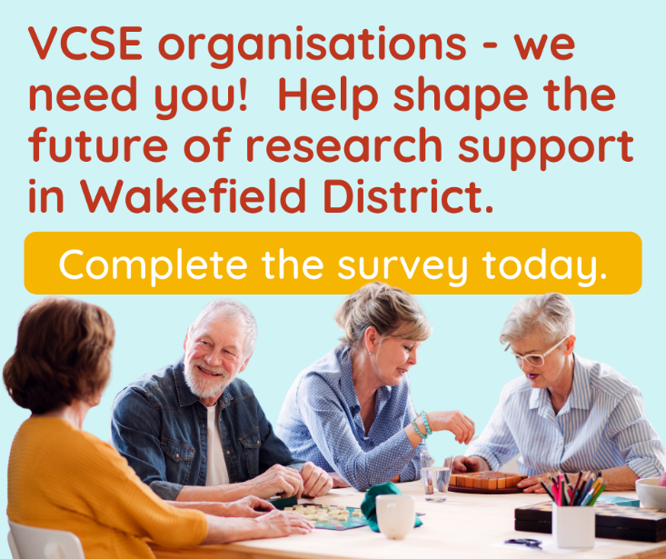
Survey to understand more about research in the Wakefield & District’s VCSE sector
Survey deadline: Fri 18 April
Click here to see and complete the survey
NIHR Health Determinants Research Collaboration Wakefield is building capacity across Wakefield & District to do research and use evidence to address health inequalities, including in the voluntary, community and social enterprise (VCSE) sector. This survey seeks views from VCSE organisations in Wakefield & District about their experiences and knowledge of research, evaluation, evidence, and data to shape a training and support offer.

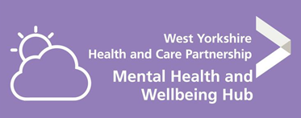
Racial trauma training with the WY Mental Health and Wellbeing Hub
Date: Thursday 1 May from 9.30am – 4.30pm
To register email wyhubstaffsupport@bdct.nhs.uk

The West Yorkshire Staff Mental Health and Wellbeing Hub are offering training to staff working in health and social care within the West Yorkshire region (NHS and VCSE). The training will be on racial trauma to recognise this still exists today and can negatively impact a person’s wellbeing and aims to develop your understanding on what racial trauma is and the impact this can have on individuals.

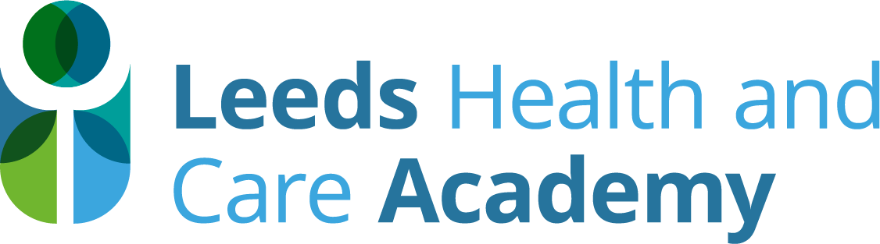
Vacancies
Your chance to join the Leeds Health and Care Academy – there are two roles available!
The Leeds Health and Care Academy was created in recognition that a step change was needed to tackle workforce challenges, and maximise the opportunities that a joined-up approach could bring. Our work spans learning and development for the current workforce, supporting candidates moving into or across health and care organisations in Leeds, and working alongside partners on collaborative workforce projects that have been designed to strengthen our effectiveness as a system. Our ambition is for Leeds to be the best city for training and working in the sector, with progressive, diverse careers for all students and staff, inspiring the next generation of health and care workers. Click here to read more about us.

We have two exciting jobs available to help us on our journey…

Development Lead
12-month fixed term or secondment opportunity
Hours: Full-time (37.5 hours) or Part-time (22.5 hours)
Salary: £46,148-£52,809
Location: Hybrid with the need to work onsite in various locations in Leeds
Closing date: 07 April
Applications are via an expression of interest process. Please contact Jess Scrimshaw for further details: jessica.scrimshaw@nhs.net
The Leeds Health and Care Academy are recruiting for a project lead to support the continued development of Career Compass, the online careers platform for health and social care in Leeds. With over 800 users already registered, we are undertaking further development of the platform across West Yorkshire, including developing a virtual career decision tool. The decision tool will support people in the workforce with health conditions to navigate career changes and transitions, for example, a student imminently entering the workforce, looking for a new role, preparing for retirement. Please see the document below for more information:
--------------------------------------------------
Talent Pipeline Officer
12-month fixed term or secondment opportunity
Hours: Full-time (37.5 hours) or Part-time (22.5 hours)
Salary: £37,338-£44,962
Location: Hybrid with the need to work onsite in various locations in Leeds
Closing date: 11 April
To find out more or apply, please send your CV to Michelle Stanley (Head of Leeds One Workforce): michelle.stanley1@nhs.net
The Talent Hub is a City Wide service that connects the people of Leeds with careers, education and training opportunities in the Health and Social Care Sector. The Talent Hub supports candidates to navigate their way through the variety of roles and opportunities available within the health and care sector in Leeds ensuring that they make an informed & supported decision as to which is the right pathway for them. For more information, please see the PDF below:
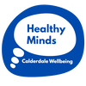
Healthy Minds (Calderdale Wellbeing) is recruiting!
Healthy Minds is the working name of Calderdale Wellbeing, a mental health charity based in Halifax, West Yorkshire. We define mental health not just as the absence of distress but as a state of wellbeing in which each person realises their own potential. We recognise different factors can affect people's wellbeing and so we provide a range of services for people according to their needs.

Only 25-35% of people with mental health problems access treatment at all; the remainder self-manage to varying degrees of success. Healthy Minds offers a service to anyone who identifies as having mental health need. We believe people are always doing the best they can and, provided with opportunities and support, they can thrive.

We are recruiting for two Project Worker roles. For full details on these roles, including how to apply, please visit the Jobs page on the Healthy Minds website: Jobs - Healthy Minds Calderdale

Like Minds Project Worker
19.5 hours per week, work pattern negotiable. £15 per hour + 5% pension; £15,210 actual salary (£29,250 pro rata). This is a fixed-term position for up to 6 months to 30th September 2025. Deadline for completed applications: 9.00am Monday 7th April.
Like Minds works with volunteers who have lived experience of emotional distress to provide opportunities for people to access peer support. This role is to work on a new, pilot phase of Like Minds to test a new offer, providing consultancy, training and ongoing support for people who want to generate peer support in their communities. The service aims to ensure that community-led peer support is psychologically safe and sustainable for all involved.

As this is a pilot project, future prospects depend on successful outcomes and securing further funding. This is an opportunity to be part of shaping up a new direction for peer support in Calderdale.

We have also re-opened rolling recruitment for Safespace Relief Workers.

--------------------------------------------------

Safespace Project Worker
18 hours per week (3 x 6-hour shifts). Daytime and evening shifts on rota, including weekend shifts. £15 per hour + 5% pension; £14,040 actual salary (£29,250 pro rata). Post funded to September 2027. Deadline for completed applications: 9.00am Monday 14th April.
Safespace is our crisis support service, providing ‘in the moment’ emotional support for anyone in Calderdale aged 16+. Safespace runs every day of the week to try to ensure that people can get support when they need it: there are no referral criteria and no waiting lists.

Safespace Project Workers are on the frontline, speaking by phone, text and face-to-face with people who are in distress. If you have the skill and temperament for what can be a demanding and rewarding role, you could be joining the Safespace team to support Healthy Minds’ vision for everyone in Calderdale to have better mental health.

Other information

West Yorkshire Mental Health Helpline only accessible via NHS 111
Since the introduction of NHS 111 for mental health crisis in 2024, the West Yorkshire Mental Health helpline has been accessible via 111 as well as via an 0800 number.

Since 1 April 2025, the service can only be reached by calling NHS 111. Anyone calling the 0800 number from 1 April 2025 will hear the following message: “This number is now closed, for people with a mental health crisis, please dial 111 and select the mental health option. If you or someone you care about is in a life threatening condition, please call 999.” This change only relates to the change in telephone number to access the service from 0800 to 111, calls will be answered by the same team, experienced and trained in delivering mental health crisis support.

This will take effect in Calderdale, Kirklees, Leeds, Barnsley and Wakefield District. Please remove the 0800 number from advertising of the West Yorkshire Mental Health Helpline and replace with 111 please.

111 is not an emergency service. In a mental health emergency where there is an immediate threat to life, call 999. Other crisis lines (listed below) remain unaffected by this change and access to these services will continue through both 111 and locally established numbers:

Bradford First Response – crisis service
0800 9521181
We offer crisis support 24 hours a day, seven days a week to people of all ages living in Bradford, Airedale, Wharfedale or Craven experiencing a mental health crisis. This service is for people of all ages living in Bradford, Airedale, Wharfedale or Craven. You do not have to have used any mental health services before to contact us. Trained professionals are just a phone call away. You can now also call 111 and select the mental health option.

Night OWLS
The overnight service for children, young people and their families and carers. Open 8pm-8am every day. Call free 0800 1488244, text 07984 392700 (charges may apply) or online chat at www.wynightowls.org.uk . During the day, children and young people in crisis should use NHS 111 mental health option. The answering service will direct them to the appropriate support.

Leeds CAMHS Crisis Call Line Team
0800 953 0505
Leeds CAMHS (Child and Adolescent Mental Health Services) Crisis Call Line is a mental health helpline for people aged under 18 in Leeds, open every day from 8 am to 8 pm. This helpline is for young people who are already known to Leeds CAMHS and those who haven’t already been referred or used the service.

We have updated our website Get help :: West Yorkshire Health & Care Partnership (wypartnership.co.uk) and the Together We Can website with information about the service.

Please find below a communications toolkit that you may want to adapt for communicating the above:


Share your case studies in the Yorkshire Policy Innovation Partnership (YPIP) newsletter across with academic, local government, health, business and community contacts across the region
YPIP works to enhance collaboration between university academics and policymakers in Yorkshire and the Humber to develop evidence-based policies that benefit local communities. It is a project that builds on the existing partnership working between academia, local government, health and community organisations in Yorkshire and the Humber across the 4 Mayoral Combined Authorities: York and North Yorkshire, Hull and East Riding, South, and West Yorkshire.

As part of this, YPIP have started a newsletter going to academic, local government, health, business and community contacts across the region. It goes out on the 1st Monday of each month. Please follow this links for the previous newsletters circulated so far:
- February 2025 - https://mailchi.mp/17dbc4f8d8af/yorkshire-policy-innovation-partnership-ypip-monthly-newsletter
- March 2025 - https://mailchi.mp/bbe24ec37a33/monthly-update-yorkshire-policy-innovation-partnership-newsletter

The newsletter looks to share project highlights/updates/upcoming opportunities, case studies of initiatives and projects across the region that link with YPIP’s themes and related events and policy updates. YPIP also wants to create a central point to share case studies and best practice that align with its 5 overarching project themes:
1. Collecting and Utilising Community Data - examples of new ways of collecting and analysing different types of findings and insights; active community participation in gathering evidence for informed decision making; communities having ownership of their data; moving away from practices of extracting data from communities
2. Good Work and Better Business - examples of bringing together communities and employers to break down barriers to the workforce; initiatives supporting marginalised groups into work; working with businesses to incorporate social impacts into their growth plans; exploring inclusive recruitment
3. Culture and the Creative Industry - examples of diverse cultural practices and community approaches to creativity; working with the creative industry on business support for the sector to survive and thrive; projects opening up pathways for creative careers
4. Climate-Ready Places - examples of environmental projects across the diverse settings in Yorkshire and Humber; approaches to retrofit and exploring barriers; community-led approaches to using land in neighbourhoods for biodiversity and wellbeing; communities exploring ways of being more sustainable to reach net-zero
5. Communities In Their Places - examples of community-led and peer research; communities working with academics and policy makers on decision making; communities being involved in the policy making process; communities being placed at the heart of service delivery and planning

Follow this link to submit a case study to the newsletter - https://forms.office.com/e/e3yNxmHsaK

Please share this with your networks so we can be sharing their great work with academic, local government, business and community contacts across the region!

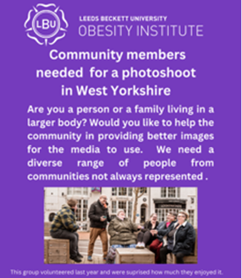
Community members needed for photo shoot (8-9 April)
Leeds Beckett University is looking for community members who might be interested in taking part in a photo shoot on 8 and 9 April to help provide respectful and non-stigmatising images of living with obesity or overweight.

We have funded the project as part of our work to tackle weight related stigma across West Yorkshire. Anyone who takes part will be paid for their time and any out of pocket expenses.

Anyone interested in taking part can contact Aly on A.Lake@leedsbeckett.ac.uk


All things Stroke website launches for local stroke patients, families and carers
The West Yorkshire Association of Acute Trusts (WYAAT) launched the new ‘All Things Stroke’ website, to support local patients, their families and carers with resources and support relating to stroke. Designed in collaboration with local stroke survivors, the VCSE sector, and healthcare professionals across WYAAT, the website acts as a ‘one-stop-shop’ and online directory for stroke advice and information, as well as support groups which can be filtered via location to show results in a user’s local community.

All health and care partners, particularly GPs, care coordinators and social prescribers, are encouraged to signpost stroke patients to this new resource and are also welcomed to offer feedback if they feel any information or support is missing from the website. Please contact matt.spencer4@nhs.net, Integrated Stroke Delivery Network Manager, for any queries or suggestions. More information is available here.

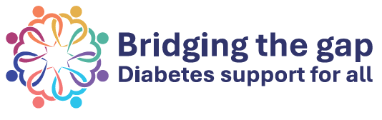
A Guide for improving digital support for South Asian and Black African or Caribbean communities living with type 2 diabetes
Type 2 diabetes is common among South Asian and Black African or Caribbean populations. National guidance recommends self-management programmes for people with type 2 diabetes, however, the number of people that take part is low, especially among ethnic minority populations.

The use of digital technology to manage long-term conditions, such as type 2 diabetes, is becoming more popular. However, studies show that access is not equally shared, and most digital health apps aren’t designed for underserved communities worsening inequalities in healthcare. This guide offers suggestions for creating digital health programmes and improving the availability/access to digital support to meet the needs of people from South Asian / Black African / Caribbean communities managing their type 2 diabetes.

