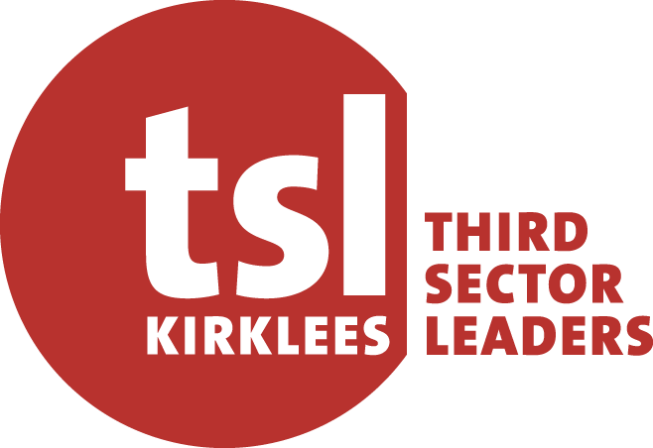

Community Anchor
Local Area Partnership
13th May 2026 – 31 March 2029

Declaration Form

This declaration form will help TSL Kirklees to understand your eligibility for the Community Anchor programme.
Please complete the following information about each partner’s policies and procedures, insurance policies and any insolvency and fraudulent activity.
- Policies and procedures
Please respond to the statements below in relation to your organisation, any of the individual Directors of your organisation or any other person who has powers of representation or control in relation to your organisation.
If you answer Yes to any of the statements below, you will need to provide supplementary information to support your application.
Please note the name of the partner organisation at the top and tick Yes or No against the following statements.

Partner 1 Organisation Name:
Statement | Yes | No
- Our organisation operates within the borough of Kirklees
- Our organisation has up-to-date Safeguarding Policy and Procedures (including Prevent)
- Our organisation has a Health and Safety Policy and Procedures
- Our organisation has Data Protection and Information Sharing Policy in compliance with General Data Protection Regulations (GDPR)
- Our organisation has an Equality, Diversity and Inclusion Policy
- Our organisation has a Volunteering Policy
- Our organisation has a Complaints Policy and Procedure

Insurance cover
Question | Yes | No | Value
Does your organisation have Employers Liability Insurance as legally required
Does your organisation have both Public Liability Insurance as legally required

Do you have any other form of Insurance? (e.g. Malpractice, Abuse). If so, please note this information here along with the value of the cover.

Insolvency and fraudulent activities
Statement | Yes | No
There is an ongoing investigation relating to suspicion of fraud or irregularity under an existing contract.
Our organisation(s) is in a state of insolvency, voluntary administration, compulsory winding up and receivership, composition with creditors, company voluntary arrangements or subject to equivalent proceedings.

Partner 2 Organisation Name:
Statement | Yes | No
- Our organisation operates within the borough of Kirklees
- Our organisation has up-to-date Safeguarding Policy and Procedures (including Prevent)
- Our organisation has a Health and Safety Policy and Procedures
- Our organisation has Data Protection and Information Sharing Policy in compliance with General Data Protection Regulations (GDPR)
- Our organisation has an Equality, Diversity and Inclusion Policy
- Our organisation has a Volunteering Policy
- Our organisation has a Complaints Policy and Procedure

Insurance cover
Question | Yes | No | Value
Does your organisation have Employers Liability Insurance as legally required
Does your organisation have both Public Liability Insurance as legally required

Do you have any other form of Insurance? (e.g. Malpractice, Abuse). If so, please note this information here along with the value of the cover.

Insolvency and fraudulent activities
Statement | Yes | No
There is an ongoing investigation relating to suspicion of fraud or irregularity under an existing contract.
Our organisation(s) is in a state of insolvency, voluntary administration, compulsory winding up and receivership, composition with creditors, company voluntary arrangements or subject to equivalent proceedings.

Partner 3 Organisation Name:
Statement | Yes | No
- Our organisation operates within the borough of Kirklees
- Our organisation has up-to-date Safeguarding Policy and Procedures (including Prevent)
- Our organisation has a Health and Safety Policy and Procedures
- Our organisation has Data Protection and Information Sharing Policy in compliance with General Data Protection Regulations (GDPR)
- Our organisation has an Equality, Diversity and Inclusion Policy
- Our organisation has a Volunteering Policy
- Our organisation has a Complaints Policy and Procedure

Insurance cover
Question | Yes | No | Value
Does your organisation have Employers Liability Insurance as legally required
Does your organisation have both Public Liability Insurance as legally required

Do you have any other form of Insurance? (e.g. Malpractice, Abuse). If so, please note this information here along with the value of the cover.

Insolvency and fraudulent activities
Statement | Yes | No
There is an ongoing investigation relating to suspicion of fraud or irregularity under an existing contract.
Our organisation(s) is in a state of insolvency, voluntary administration, compulsory winding up and receivership, composition with creditors, company voluntary arrangements or subject to equivalent proceedings.

Please submit ALL partner organisation’s Employers Liability Insurance and Public Liability Insurance documents (along with documents for any other forms of insurance cover mentioned above).

DECLARATION
I confirm that the information in this declaration form is correct. Any funding awarded to partner organisations in the CALAP will only be used for the purposes and according to any conditions specified with respect to being Community Anchors.
I understand that I will need to provide additional relevant documentation on request.
Partner 1 Name: | Job title: | Date:
Partner 2 Name: | Job title: | Date:
Partner 3 Name: | Job title: | Date:

