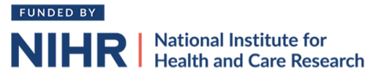
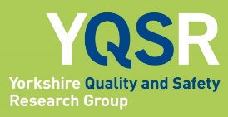
The SaSI-Meds research programme: a Single and Safe Intervention for Medication Administration within NHS hospital wards
Information about our Patient Advisory Group

What is the problem?
Every day in NHS Hospitals there are approximately 130,000 medication errors. Over three quarters of these happen while giving medicines to patients. These errors, which include giving the wrong dosage or medicine to a patient, happen frequently and may harm patients. In very rare cases they can cause severe harm or death. ‘Double checking’ is often used to reduce these errors – this is where two nurses check a medicine and dose before giving it to the patient. However, there is no convincing evidence that double-checking reduces errors. Research also shows that double checking may harm patients by causing delays to them getting critical medicines.

Nurses spend a lot of time double checking medicines (6.4 minutes per check) which is estimated to cost the NHS between £412 million and £1.28 billion per year. If double checking reduces patient harm, then this might be time well spent by nurses. But evidence shows that double checks are often not done correctly, may not work as planned, and can themselves harm patients.

What is being done about the problem?
Over the next 5 years, the Yorkshire Quality and Safety research group want to understand how double checking is currently done, how many errors happen when medicines are double checked, and what double checking costs the NHS (e.g. staff time). We will then work with staff and patients to develop a set of actions (an intervention) that encourages nurses to stop double checking and do a ‘safe single check’ instead. We will work out how to support staff, and, if this goes well, we will conduct a carefully monitored experiment to find out whether stopping double checking of medicines saves money without increasing patient harm.
How will members of the public be involved in this research?
We are creating a ‘Patient Advisory Group’ (PAG) that will contribute to this really important research. Members of the PAG will work closely with researchers and NHS staff to:
- Make ethical decisions about how we do the research
- Design materials for patients and carers involved in the research
- Help develop an intervention to stop double checking of medicines
- Help decide how we test whether the new intervention works or not
- Help disseminate research findings in accessible ways

Who will be involved in the Patient Advisory Group?
The PAG will include members of the public who are passionate about improving patient care within NHS hospitals. We are looking for people who have been admitted to an NHS hospital, for a number of days, within the last two years. We are also looking for family, parents and/or carers of people who have been in hospital. We want to involve people who have / have had a range of different medical conditions, who take different types of medication, and people of different ages and ethnicities.

What does joining the Patient Advisory Group mean for me?
We hope the PAG will meet for the first time in April 2025. We will hold a training session to help everyone understand the role of the PAG, what the research is about, and what you can expect / hope to achieve by being involved. After this we will meet in person about 6 times per year (about 2 hours per meeting). These meetings are likely to be at the Bradford Royal Infirmary. You don’t have to attend every meeting and we can support you in-between meetings e.g. through phone calls, online meetings, and newsletters.
You will be paid £25 per hour (plus expenses) for your time. We would also like to understand and support your personal motivations for being involved in this research which has the potential to help NHS staff avoid patient harm and use resources efficiently.

If you are interested then please contact Ruth Baxter (programme manager) to arrange an informal chat - email r.m.baxter@leeds.ac.uk or telephone 07762376337.

